Rafif Tri Hartanto

SIB 2A

26

Jobsheet 2 Data Warehouse

Tugas 1



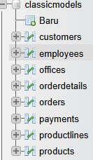

|  |  |  |
| --- | --- | --- |
| Tabel 1 | Tabel 2 | Jenis Relasi |
| Productlines | Products | One to many |
| Orderdetails | Products | One to many |
| Orderdetails | Orders | One to many |
| orders | Customers | One to many |
| Payments | Customers | One to many |
| Employees | Customers | One to many |
| Employees | Employees | One to many |
| Employees | Offices | One to many |



|  |  |
| --- | --- |
| Nama Tabel | Jumlah Field |
| Productlines | 4 |
| Products | 9 |
| Orderdetails | 5 |
| Orders | 7 |
| Customers | 13 |
| Payments | 4 |
| Employees | 8 |
| Offices | 9 |

Tugas 2

1. Diane Murphy (1002)

├── Mary Patterson (1056)

│ ├── William Patterson (1088)

│ │ ├── Andy Fixter (1611)

│ │ ├── Peter Marsh (1612)

│ │ ├── Tom King (1619)

│ ├── Gerard Bondur (1102)

│ ├── Anthony Bow (1143)

│ ├── Mami Nishi (1621)

│ ├── Yoshimi Kato (1625)

├── Jeff Firrelli (1076)

Anthony Bow (1143)

├── Leslie Jennings (1165)

├── Leslie Thompson (1166)

├── Julie Firrelli (1188)

├── Steve Patterson (1216)

├── Foon Yue Tseng (1286)

├── George Vanauf (1323)

Gerard Bondur (1102)

├── Loui Bondur (1337)

├── Gerard Hernandez (1370)

├── Pamela Castillo (1401)

├── Larry Bott (1501)

├── Barry Jones (1504)

├── Martin Gerard (1702)

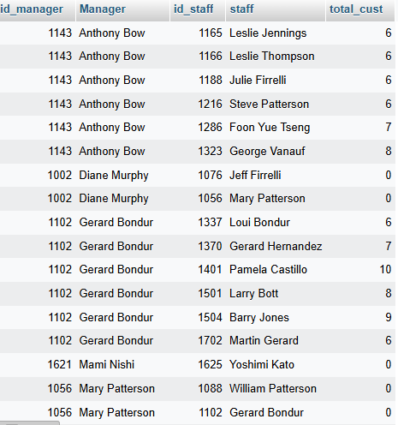

Tugas 3

1. Pamela Castillo





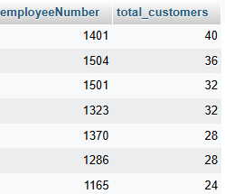

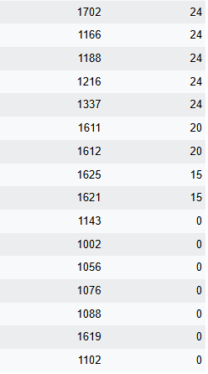



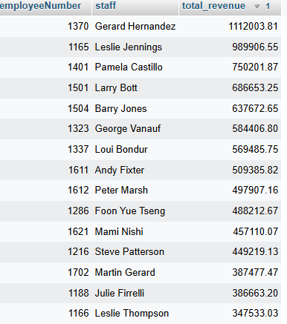



|  |  |
| --- | --- |
| KPI | Jumlah Field |
| Jumlah customer yang bertransaksi | 1 (customerNumber) |
| Jumlah omset yang didapat | 1 (amount) |



|  |  |  |  |
| --- | --- | --- | --- |
| Nama | 2003 | 2004 | 2005 |
| Foon Yue Tseng | 221887.03 | 237255.26 | 29070.38 |
| Pamela Castillo | 317104.78 | 409910.07 | 23187.02 |

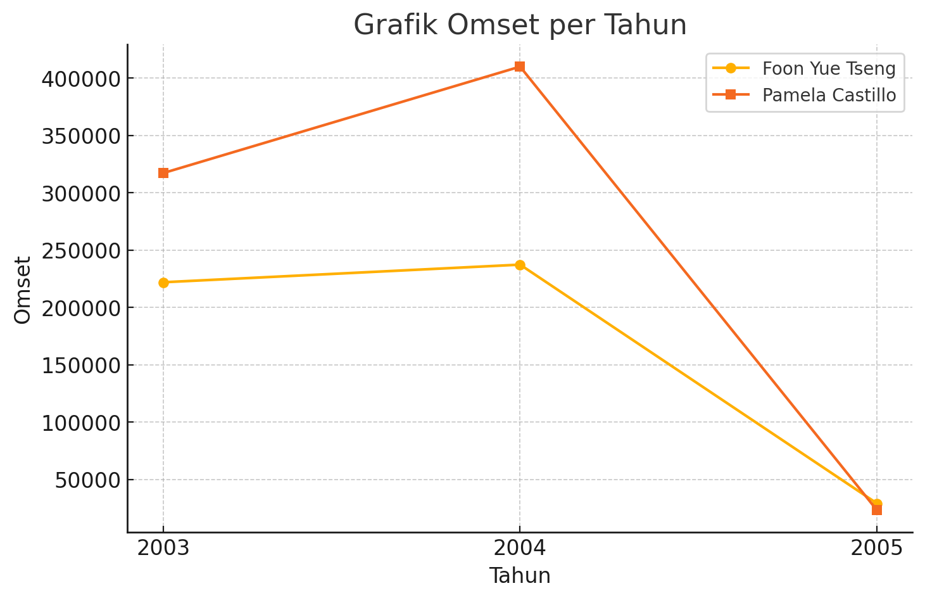

Studi Kasus

|  |  |  |  |
| --- | --- | --- | --- |
| Nama Cabang | 2003 | 2004 | 2005 |
| Boston | 301781.38 | 467177.07 | 66923.88 |
| London | 505384.85 | 674815.75 | 144125.30 |
| NYC | 391175.53 | 623872.78 | 57571.16 |
| Paris | 969959.90 | 1368458.96 | 480750.04 |
| San Francisco | 532681.13 | 517408.62 | 287349.83 |
| Sydney | 281985.51 | 509833.62 | 215473.85 |
| Tokyo | 267249.40 | 151761.45 | 38099.22 |